RFID Hall Pass – Final Project

Christopher Yang, Lautaro Stamati

Week 1 – 4/11/2025

Executive Summary:

- This week, we entered the planning stage, which included the beginning of simulating and mapping out circuit designs using Electronic Design Animation (EDAs). Scouting for a viable option that included the specified breakout boards was the main goal.

- TinkerCAD did not offer support for the sensors and devices needed. Some open source softwares like Fritzing had lackluster support and website options were abysmal in terms of user interface. Finally, CirkitStudio met our needs, with specific boards from specific manufacturers that fit the simulation needs for this project.

- We developed a rough schematic for a circuit design, implementing a RC522 RFID Reader/Writer and an NRF24L01. Below is the CirkitStudio schematic of the prototype design.

Schematic:

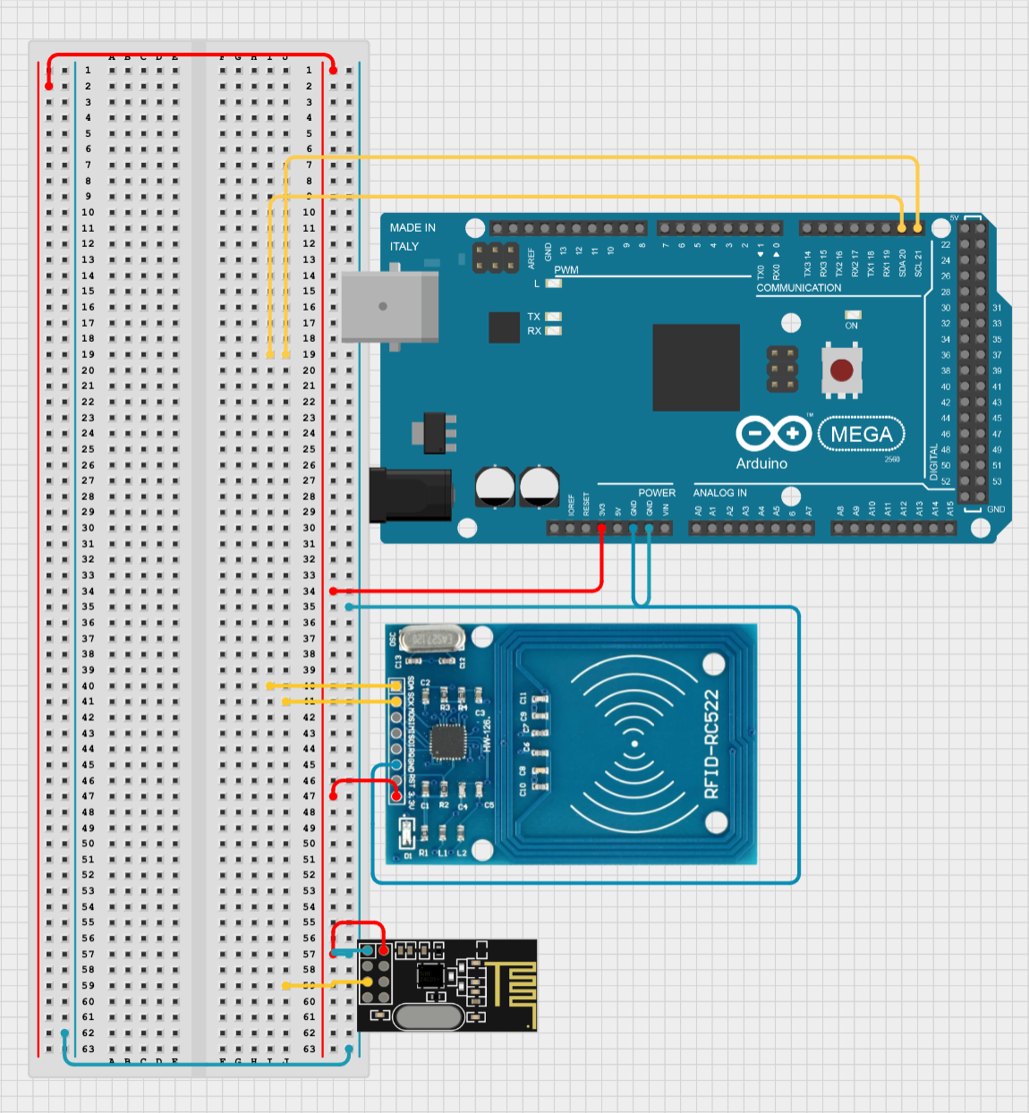

Gantt Chart & Planning:

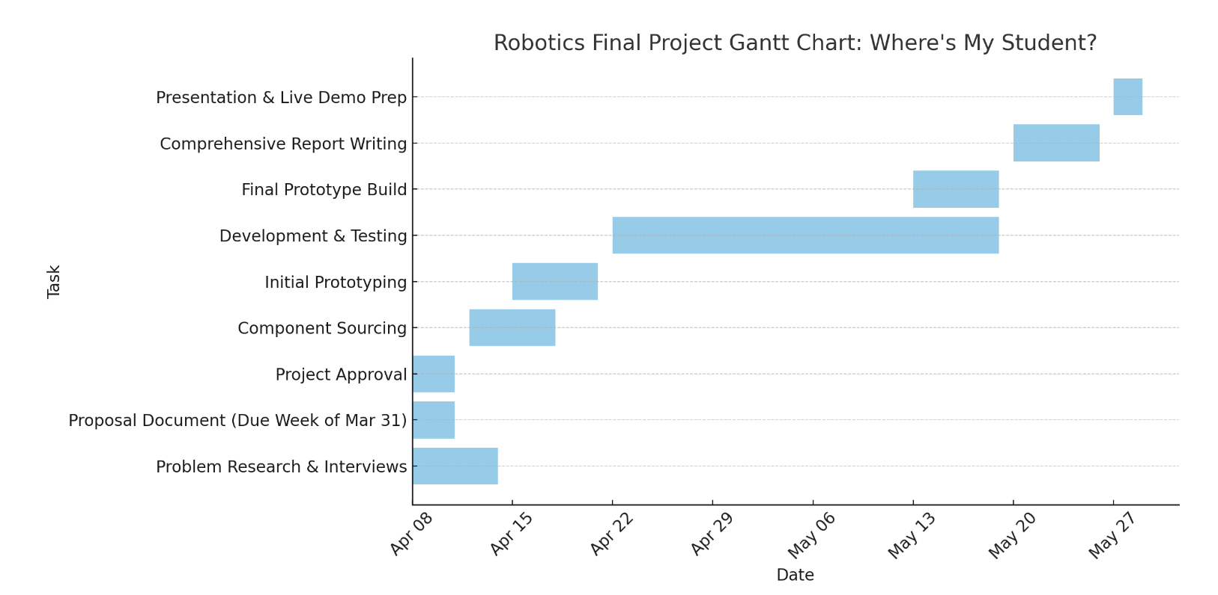

- Next week, the team’s goal is to develop a rough code that can be run inside the chosen EDA. Once both circuitry and programming aspects are completed within the simulator, the development team can move onto prototyping on a physical breadboard/circuit.